### User Information

The *User Information* section of the *Edit User* screen contains all of the demographic information for a particular user. When editing a user’s info, fill out the textboxes with the appropriate information.

Note: After entering any information in the *User Information* section, you must click **Save Changes**, or new info will not be recorded.

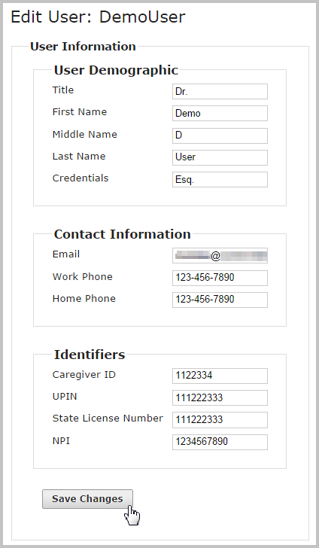

Although only first name, last name and email address are required to create a new user, all available user information should be entered. Contact information is extremely important for support purposes. Email and work phone should always be included whenever possible. For providers, NPI should be included.